# ASSIGNMENT NO:2

NAME: DHANUSH R

PROJECT NAME: PLASMA DONOR APPLICATION

DOMAIN NAME: CLOUD APPLICATION DEVELOPMENT

TEAM ID: PNT2022TMID26173

# 1. Create form of input text ,email, password radio button text area drop down and navigate to success page and display files of form in tables(html, css)

DOCTYPE html>

<html>

<head>

<title>Display Selected HTML Table TR Values In Input Text</title>

<meta charset="UTF-8"><!

<meta name="viewport" content="width=device-width, initial-scale=1.0"<style>

table tr:not(:first-child){

cursor: pointer;transition: all .25s ease-in-out;}

table tr:not(:first-child):hover{background-color: #ddd;}

</style>

</head>

<body>

First Name:<input type="text" name="fname" id="fname"><br><br> E-Mail id: <input type="email" name="email" /><br> <br>

Password: <input type="password" name="pwd" /><br> <br> Age:<input type="number" name="age" id="age"><br><br>

Gender:<input type="radio" name="gender" />Male<br><input type="radio" name="gender"

/>Female<br><br>  
Address:<textarea> </textarea><br><br>

<table id="table" border="1">

<tr>

<th>First Name</th>

<td>FN1</td></tr>

<tr>

<th>Email</th>

<td[>abc@g](mailto:abc@gmail.com)m[ail.com](mailto:abc@gmail.com)</td>

</tr>

<tr>

<th>Password</th>

<td> 12345678</td>

</tr>

<tr>

<th>Age</th>

<td>18</td>

</tr>

<tr>

<th>Gender</th>

<td>female</td></tr>  
<tr><th>Address</th><td> </td>

</table>

</body>

</html>

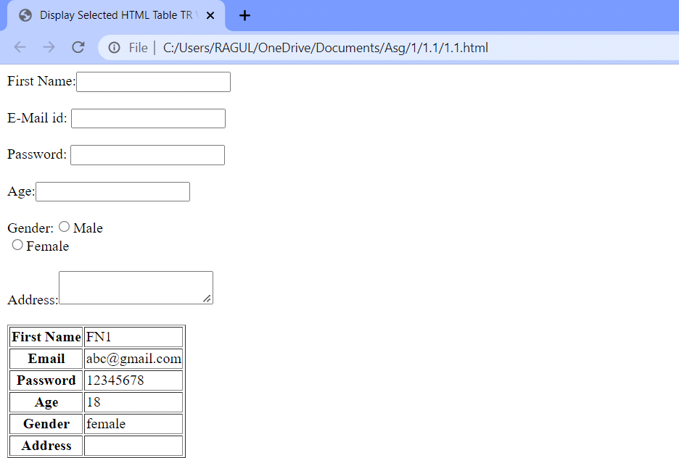

2. for css create external style sheet for above task(seperate file and link that in html.

**HTML file**

<!DOCTYPE html>  
<html>  
<head>  
<link rel="stylesheet" type="text/css" href="style.css">  
</head>  
<body>  
<h2>Demo Text</h2>  
<div>  
<ul>  
<li>This is demo text.</li>  
<li>This is demo text.</li>  
<li>This is demo text.</li>  
<li>This is demo text.</li>  
<li>This is demo text.</li>  
</ul>  
</div>  
</body>  
</html>

**CSS file**

h2 {  
 color: red;  
}  
div {  
 background-color: lightcyan;  
}

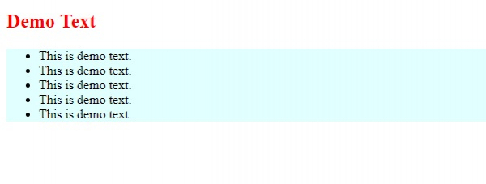

# 3.Flask HTTP methods

**Login.html**

<html>

<body>

<form action = "<http://localhost:5000/login>" method = "post">

<table>

<tr><td>Name</td>

<td><input type ="text" name ="uname"></td></tr>

<tr><td>Password</td>

<td><input type ="password" name ="pass"></td></tr>

<tr><td><input type = "submit"></td></tr>

</table> </form>

</body>

</html>

**from flask import \***

app = Flask(__name__)

@app.route('/login',methods = ['POST'])

**def** login():

uname=request.form['uname']

passwrd=request.form['pass']

**if** uname=="ayush" **and** passwrd=="google":

**return** "Welcome %s" %uname

**if** __name__ == '__main__':

app.run(debug = True)

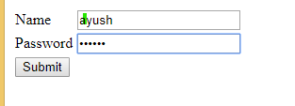



GET Method

<html>

<body>

<form action = "<http://localhost:5000/login>" method = "get">

<table>

<tr><td>Name</td>

<td><input type ="text" name ="uname"></td></tr>

<tr><td>Password</td>

<td><input type ="password" name ="pass"></td></tr>

<tr><td><input type = "submit"></td></tr>

</table>

</form>

</body>

</html>

app = Flask(__name__)

@app.route('/login',methods = ['GET'])

**def** login():

uname=request.form['uname']

passwrd=request.form['pass']

**if** uname=="ayush" **and** passwrd=="google":

**return** "Welcome %s" %uname

**if** __name__ == '__main__':

app.run(debug = True)



